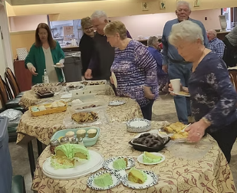

**MERA**

Anniversary Luncheon

Thursday, April 24

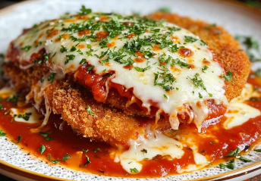11:00 AM – 2:00 PM Cash Bar

11:30 AM – 12:00 PM Business Meeting

12:00 PM – 2:00 PM Luncheon

**Price just $15 per person!**

**Victor Emmanuel (311 Hazel St. Reading)**

**HOT BUFFET Includes:**

**Salad, Pizza, and Chicken Parmesan w/Pasta Dish. Soft drinks and coffee.**

**Please bring a dessert to share!**

**DEADLINE for reservations is Thursday, April 17th 2025**

(If you received this flyer electronically, and have a printer, please print the form. If not, simply include a note with the required information along with your check.)

Make Checks Payable to: MERA

Mail lower section to: Gary Pleiss, 41 Fieldstone Lane, Fleetwood, PA 19522

Call (610) 927-7590 with any questions.

**Cut**…XXXXXXXXXXXXXXXXXXXXXXXXXXXXXXXXXXXXXXXXXXXXXXXXXXXXXXXXXXXXXXXXXXXXXXXXXXXXXXXXX

MERA Anniversary Luncheon 2025

Members & Guest @ $15 each ______ Total $ __________

Member Name ______________________Phone Number __________________

Looking forward to seeing you there!